1. The url that we will use is: <https://recipes.lewagon.com/>

What is the scheme, host and path of this url?

* + Scheme is **https**
  + Host is [recipes.lewagon.com](https://recipes.lewagon.com/)
  + No path in this URL

1. Use Insomnia to create an HTTP request from this url. What status code do you get?

Status code is 200 "OK"

1. Use your web browser and go to <https://recipes.lewagon.com/>, click on a specific recipe.

Look at the url you get. What is the generic path for a recipe ? What is the code after?

* + One specific recipe gives the url: <https://recipes.lewagon.com/recipes/668>
  + The path is **recipes/**
  + The unique code after is the id of the recipe.

1. Use Insomnia and try to request a recipe page that doesn’t exist.

What is the status code you get?

Error 404

1. Go to the homepage and search for “chicken” in the search bar?
   * Has the url changed?

[https://recipes.lewagon.com/?search[query]=chicken&button=](https://recipes.lewagon.com/?search%5Bquery%5D=chicken&button=)

* + What is the scheme, host and path of this url?

Scheme: https

host: [recipes.lewagon.com](https://recipes.lewagon.com/?search%5Bquery%5D=chicken&button=)

* + Can you find any query parameters? → If yes, list them 📝

1 query parameter: search[query] and value is “chicken”

1. In Insomnia, make a GET API request on the last url that you obtained when searching for “chicken”. Put the parameters to the query tab instead of the url. What status code do you get?

Status code is 200 "OK"

1. You now have a good understanding of query parameters!  
   If you want results from the next page, what query parameter should you add?

Query parameter page=2 is useful to paginate results. Indeed, when there are a lot of results, it can be too heavy for a web browser to deal with such amount of data.

1. Use Insomnia to do the request.

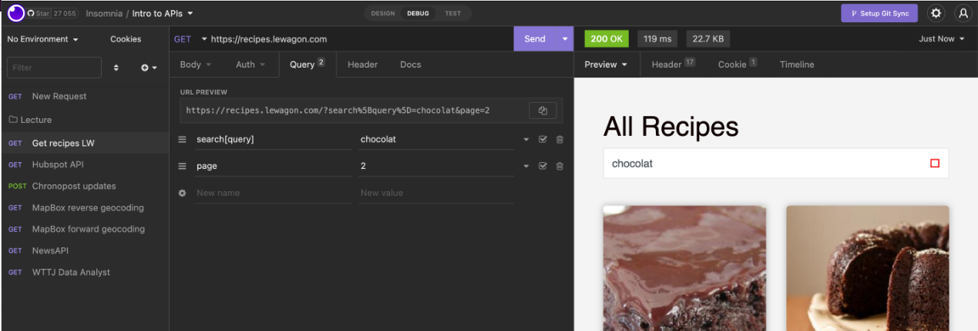

What happens when you query results from page 50? Is it what was expected?

get the results from the home page.